Academic Year: 2025-26 | Year: Second Year | Semester: II
PRN No.: 1012411011 | Name: Riddhee Kulkarni
Subject: Python Programming
Assignment No.: 6
Date: 29/12/2025

Lab Assignment: 06
Aim:
To write a Python program that prompts the user to enter a number between 1 and 7 and displays the corresponding day of the week.

Objective:
- To understand the use of conditional statements in Python.
- To map numeric input to meaningful textual output.
- To practice decision-making using if-elif-else statements.
- To handle invalid user input effectively.

Theory:
Conditional statements in Python allow a program to execute different blocks of code based on specific conditions.
Using if-elif-else, a number entered by the user can be matched with a predefined value.
In this program, numbers from 1 to 7 represent the days of the week starting from Monday.
An else condition is used to handle invalid input.

Algorithm:
- Start the program.
- Input a number from the user.
- If the number is 1, display Monday.
- Else if the number is 2, display Tuesday.
- Else if the number is 3, display Wednesday.
- Else if the number is 4, display Thursday.
- Else if the number is 5, display Friday.
- Else if the number is 6, display Saturday.
- Else if the number is 7, display Sunday.
- Else, display an invalid input message.
- Stop the program.

Pseudo Code:
START
READ number
IF number == 1
PRINT "Monday"
ELSE IF number == 2
PRINT "Tuesday"
ELSE IF number == 3
PRINT "Wednesday"
ELSE IF number == 4
PRINT "Thursday"
ELSE IF number == 5
PRINT "Friday"
ELSE IF number == 6
PRINT "Saturday"
ELSE IF number == 7
PRINT "Sunday"
ELSE
PRINT "Invalid input"
END

Code:
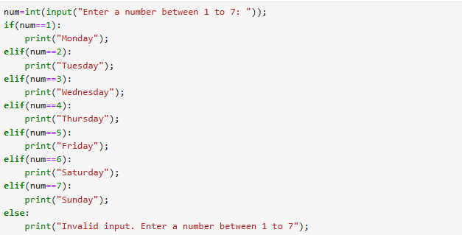

Output:

Conclusion:
The program successfully displays the corresponding day of the week based on the number entered by the user. It demonstrates effective use of conditional statements and input validation in Python. This program helps in understanding decision-making logic using if-elif-else.

